Figures for Mautz Departmental Exam Paper

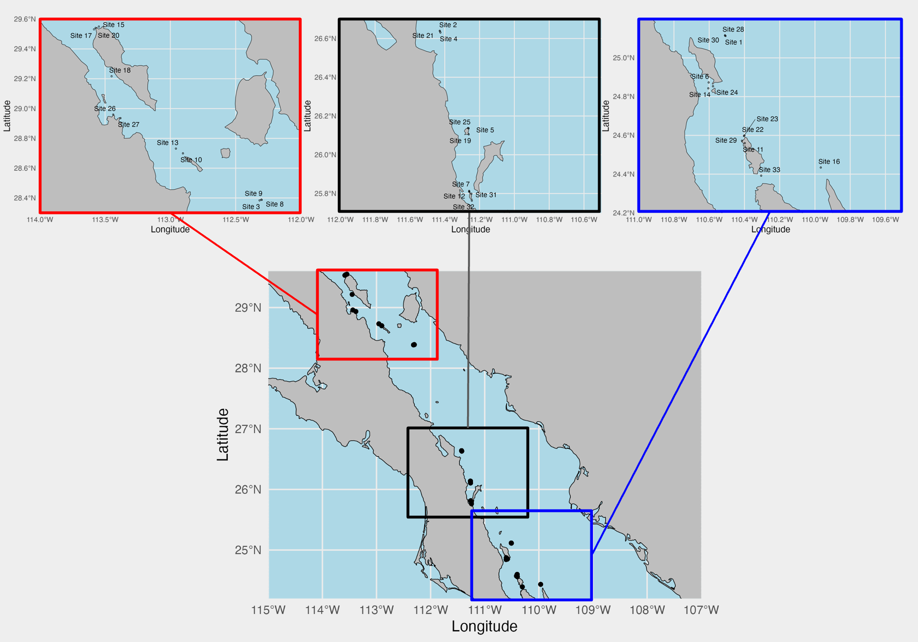

Figure 1: Map of sampling sites in the Gulf of California. Bottom map is the map of all sites. Top three maps are subset maps of three latitude groupings: northern sites (red), middle sites (black), and southern sites (blue).

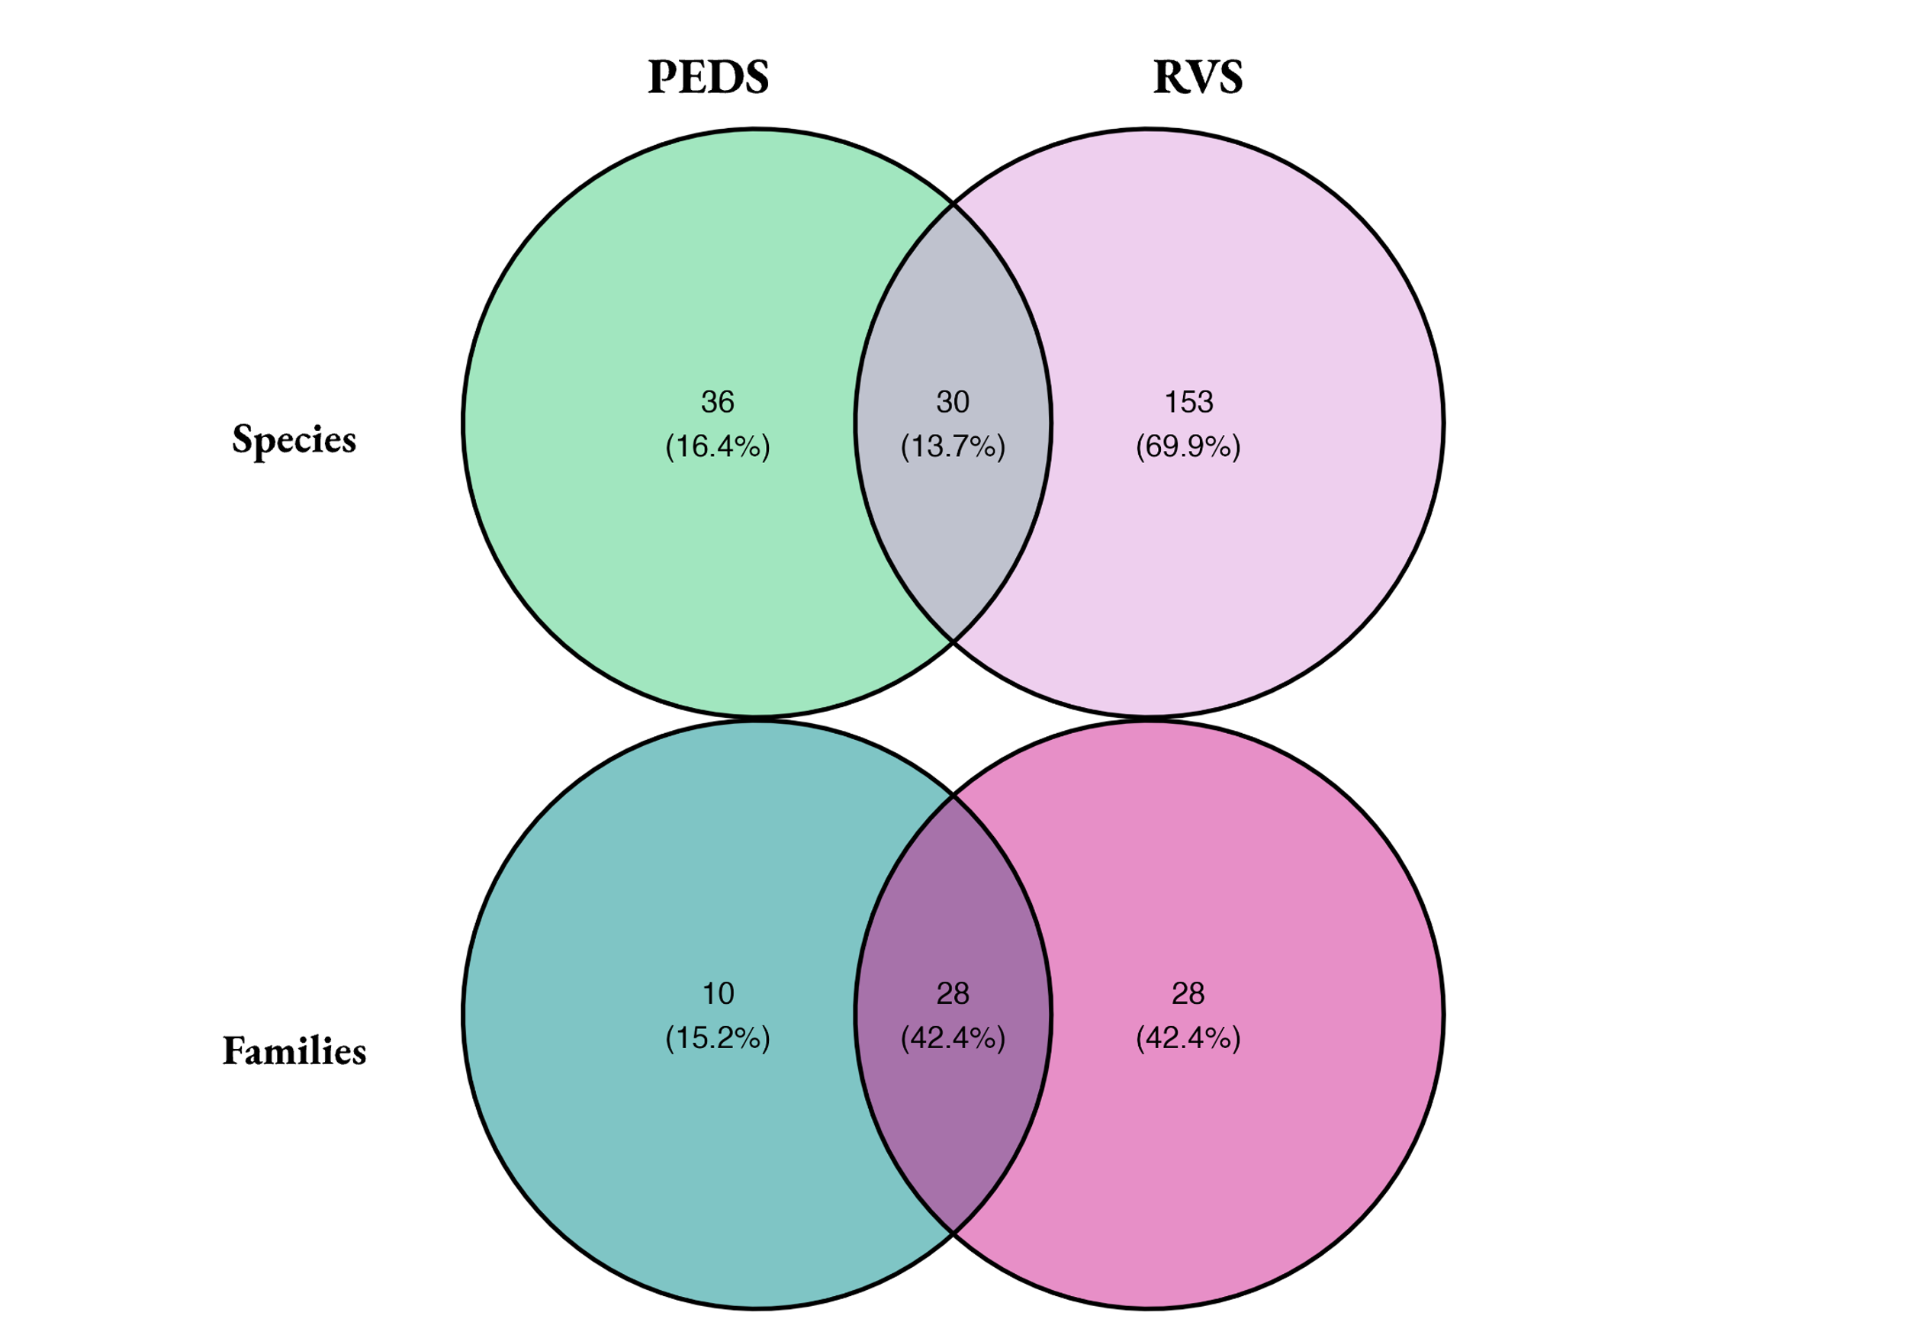

Figure 2. Venn diagrams showing species overlap (top) and family overlap (bottom) between PEDS and RVS.

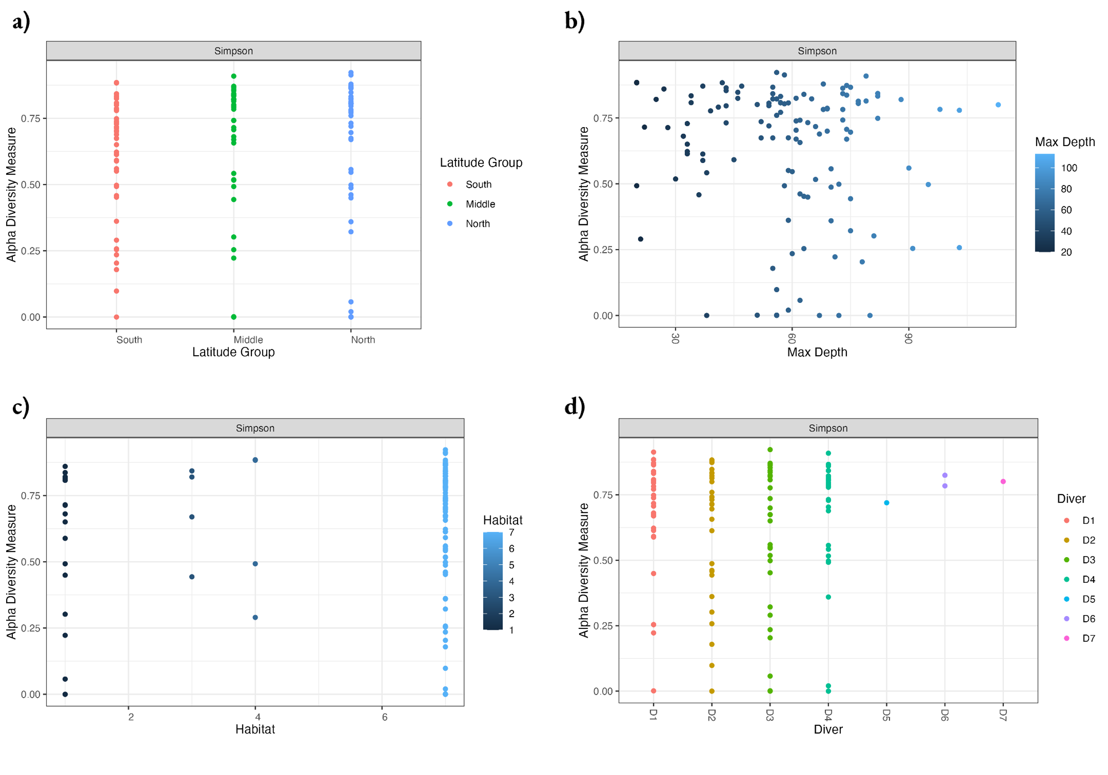

Figure 3. Alpha diversity plots for PEDS using Simpson’s diversity index for four metadata variables: latitude group (a), maximum dive depth (b), most common habitat (c), and diver (d).

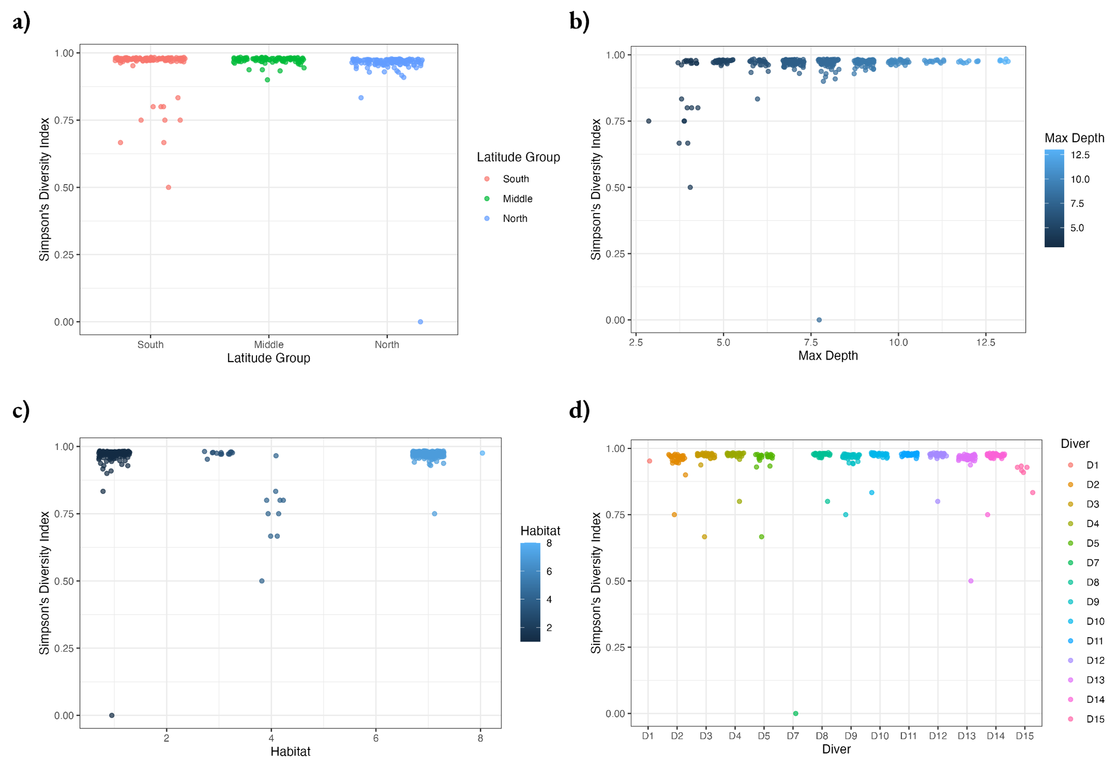

Figure 4. Alpha diversity plots for RVS using Simpson’s diversity index for four metadata variables: latitude group (a), maximum dive depth (b), most common habitat (c), and diver (d).

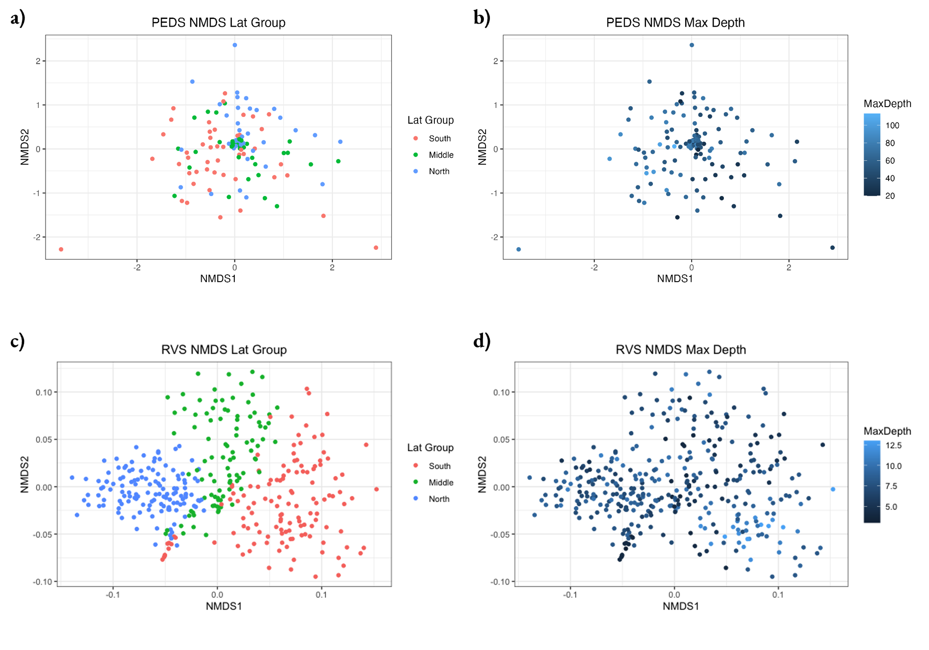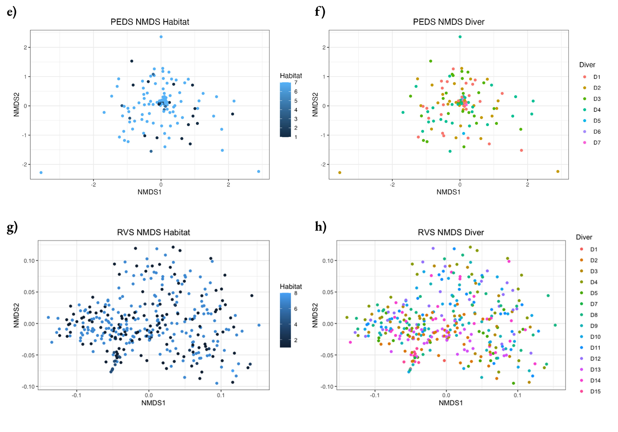

Figure 5. NMDS beta diversity plots for PEDS following Hellinger transformation of data and for RVS using Gower dissimilarity index for latitude group (a) and (c), maximum depth (b) and (d), habitat (e) and (g), and diver (f) and (h).

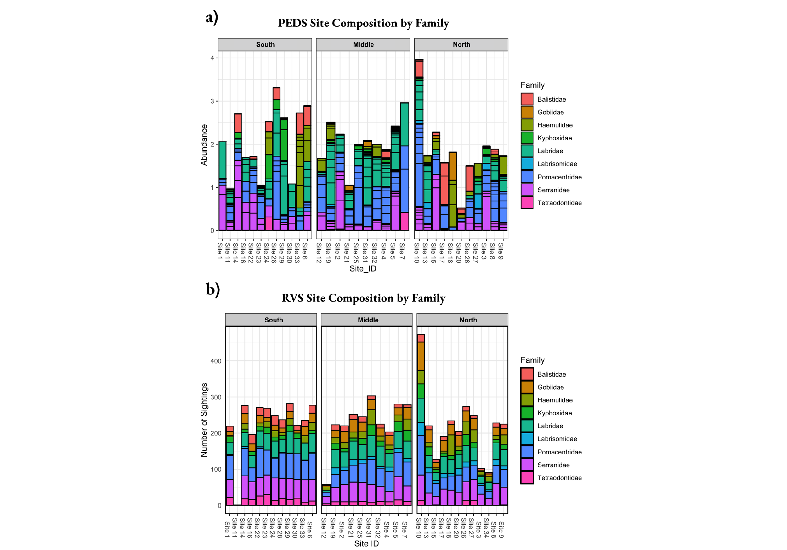

Figure 6. Family composition in each site for PEDS (a) and RVS (b) for 9 families of overlap. Note that horizontal black lines in each bar in the PEDS plot represents a species within the family.

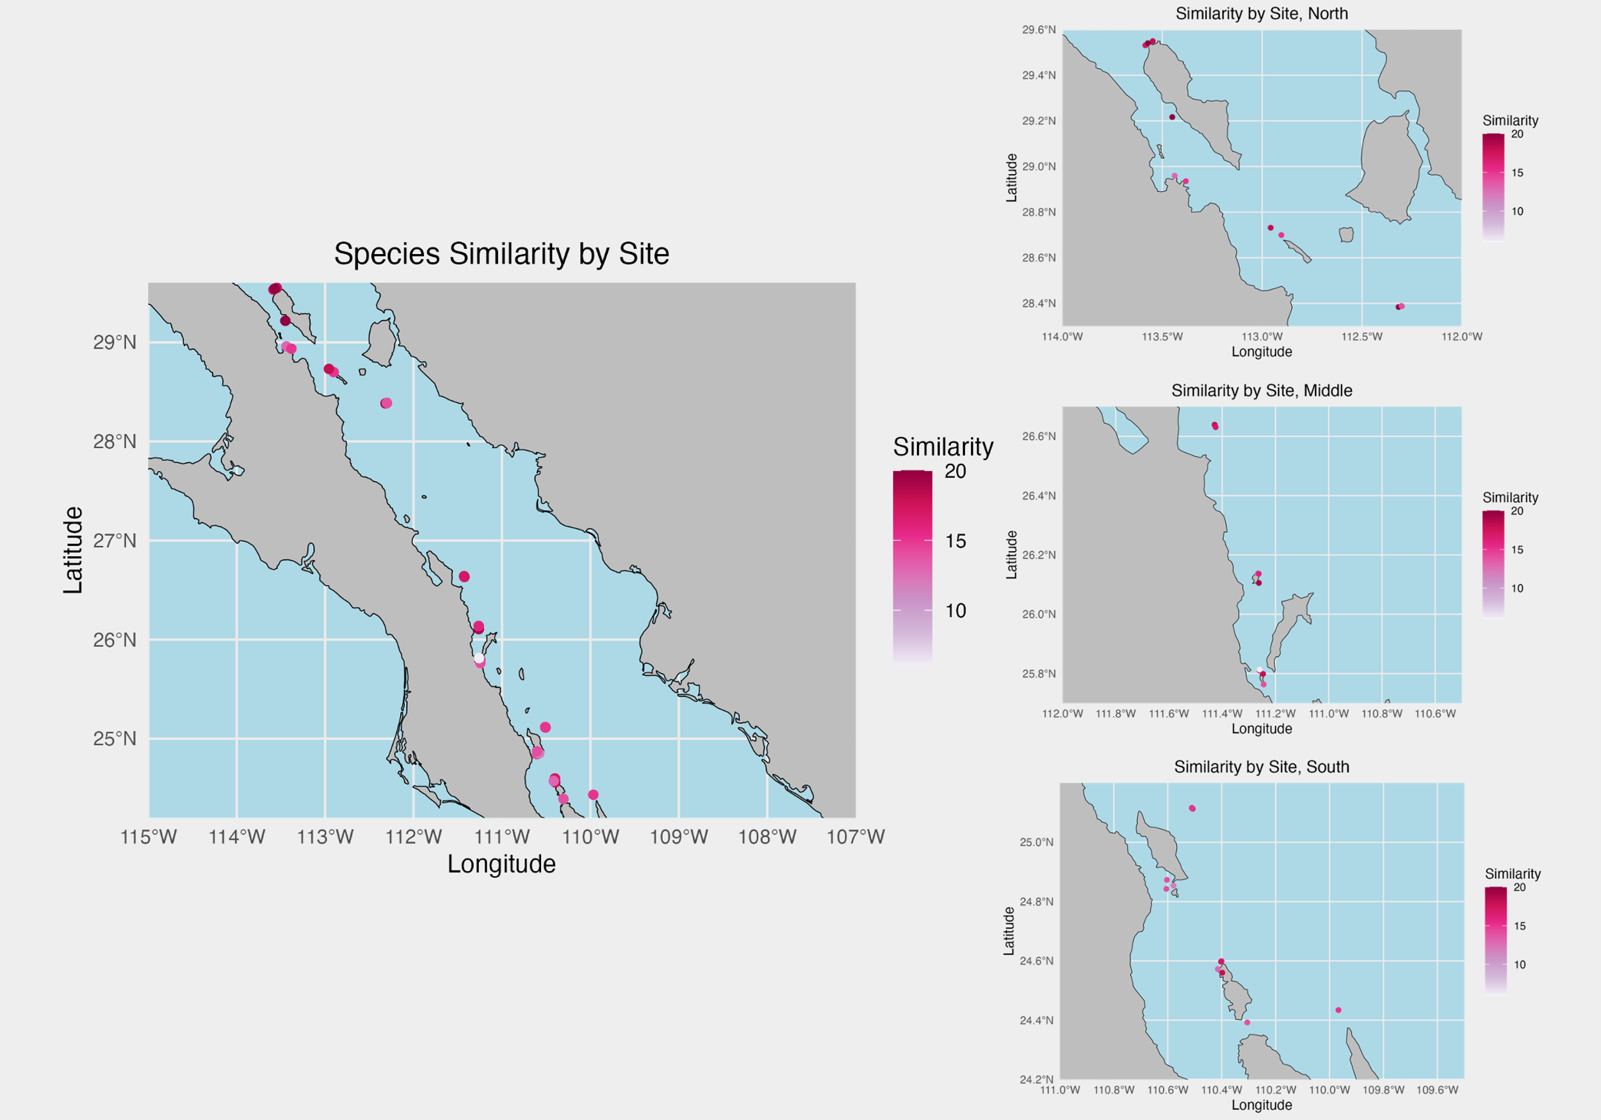

Figure 7. Heatmap depicting the number of species in each site for which PEDS and RVS had matching presence / absence data (present in both or absent in both).

Figure 8. Scatter plot with a linear regression between species overlap numbers and latitude. R2 value is 0.118 and p-value of the regression is 0.0508.